NARROGIN SENIOR HIGH SCHOOL

YEAR 11 ECONOMICS
SEMESTER 2 – 2008

SECTION B: DATA INTERPRETATION

Answer ALL THREE questions in the spaces provided in this section of your exam paper.

31. (a) Define ‘inflation rate’ and demonstrate its calculation for 2002/03. (2)
Inflation rate measures the percentage change in the general level of prices from one year to the next. One method of measurement is the CPI which approximates the extent of increases in the cost of living.
Working must be shown as well as the right answer.

E.g. 120.7 – 120.3 * 100 = 0.33%
120.3

(b) Identify the stage of the business cycle for this economy, in 2003/-4, by reference to two of the indicators shown. (3)

Recovery / upswing.
After two years of negative growth there is a positive change in GDP.
The unemployment rate has fallen, as increased output requires more workers.
Students might also mention a slight rise in inflation but it’s not the clearest indicator to choose.

(c) Describe an appropriate policy response to the economic situation of this country. (5)
Identify the ‘economic situation’.
The recovery appears to be in the early stages: growth is below what might be an acceptable level (3-4%) unemployment is higher than acceptable (5-6%) inflation is below a possible acceptable range (2-3%) and there is in fact a current account surplus.
Identify a possible policy stance: e.g.
Ensure a sustained recovery by stimulating the economy through encouraging expenditure and output and therefore further rises in income.
Existence of a current account surplus gives more freedom to embark on expansionary policy than would a large deficit.
Expansionary monetary policy through lowering or maintaining low official interest rates.
An additional fiscal stimulus might be appropriate depending upon the state of government finances and the medium term goals of fiscal policy. Tax reforms that see a fall in income tax rates could also be appropriate, improving the efficiency of the tax system and boosting disposable income, confidence and household expenditure.

  - Read the article below and then answer the questions that follow:

  - Explain the meaning of ‘sustainable development’. (1)

  - Distinguish between man made capital and natural capital. (2)

  - What is a common property resource? Why are these goods over used? (2)

  - What is meant by a sustainable yield? (2)

  - How does the price system help encourage sustainable development? (3)

33.

a) Calculate the inflation rate between the years:

i 1999 / 2000 and 2000 / 2001 _____________________________ (1)
ii 2001 / 2002 and 2002 / 2003 _____________________________ (1)

b) In the period 1999 / 2000 to 2002 / 2003 state which group in the CPI
i Recorded the greatest absolute rise in its index _____________________ (1)
ii Recorded the smallest percentage increase in its index _______________ (1)
iii State simply why these different components or groups within the CPI have different weightings attached to them. (1)

c) Discuss some of the main effects inflation can have in an economy. (5)

SECTION C: EXTENDED WRITING

Answer a total of two (2) questions (40 marks)
Your answer should consist of at least two pages of normal writing.
Suggested time for this section is 70 minutes. Answer the questions on the lined paper provided.

34. (a) What is Unemployment? How is it calculated? (2)

- Unemployment is said to exist when there are willing and able workers who can not find gainful employment.
- Unemployment Rate is the proportion of the workforce expressed as a percentage who are willing and able to work, but can not find a job.
- The Unemployment Rate is =

Number of unemployed (those over 15 seeking work) x 100 Number in labour force 1

(b) Distinguish between frictional, structural and cyclical unemployment. Give an example of each. In what sense is there a positive side to unemployment? (10)
Frictional Unemployment - always some unemployment due to workers voluntarily changing employment. Frictional unemployment – may reflect acquisition of more skills and training. Duration of unemployment depends on knowledge of labour market and efficiency of job seeking.

Cyclical Unemployment or demand-deficient unemployment occurs in the downswing and recession phases of the trade cycle. It is basically due to substantial reductions in aggregate demand or total spending in the economy. The reduction in demand for goods and services leads to a reduction in total output and ultimately results in a reduction in demand for the labour that produce those goods and services.

Structural / Technological Unemployment refers to changes in the structure of the economy over time due to technology changes and changes in the pattern and nature of consumer spending.
Technological change usually means that the demand for some types of workers increases, while others find their skills are no longer relevant.

Bank tellers under threat from automatic teller machines (ATM), the replacement of horse and carriage by the motor vehicle causing unemployment for blacksmiths are both examples of structural unemployment.

Seasonal Unemployment affects occupations such as fruit pickers, fishermen and shearers. Where the nature of their work means that employment may not be available for the whole year.
Continuous work for such workers would be highly unusual, especially for those not prepared to travel great distances.

(c) Outline the economic and social effects of unemployment. (8)

The effect of unemployment can be categorised as either social or economic.
The Economic Effect:
- Unused resources make no contribution to the production process and thus earn no income. The economy will produce less goods and services than it potentially could if resources were fully employed.
- This loss of production is often termed the GDP gap.
- The GDP gap models the effect of unemployment on the economy - lower output, resource waste, lower income levels and so on.
- Unemployment may affect future production of goods as well as current output. Machines as well as workers are idle during periods of unemployment.
- Plant and equipment become obsolete, unemployed workers lose skills (no apprenticeships) and are unable to gain new ones. This causes the quality of the workforce to decline.
Reduced Government Revenue: The size of the government’s budget deficit increases due to the increased demand for transfer payments, at a time when the pool from which to raise revenue has diminished (income tax).
- Though the dole represents a direct benefit to the recipient, there are foregone economic benefits (an opportunity cost) of such spending.
- The opportunity cost might be spending in the areas of education, transport and communication, which would bring greater long term benefits to the economy.
Redistribution of Income:
- Increases in unemployment leads to a decrease in income for low skilled and workers in declining industries and sectors.
- Those in secure employment may also benefit from deflation (or slower inflation) as it causes their real incomes to increase.

35. (a) Explain the role and function of each of the following sectors in the circular flow of income. Use diagrams.
a. Households
b. Firms
c. Capital market
d. Government
e. Overseas (12)

Circular Flow

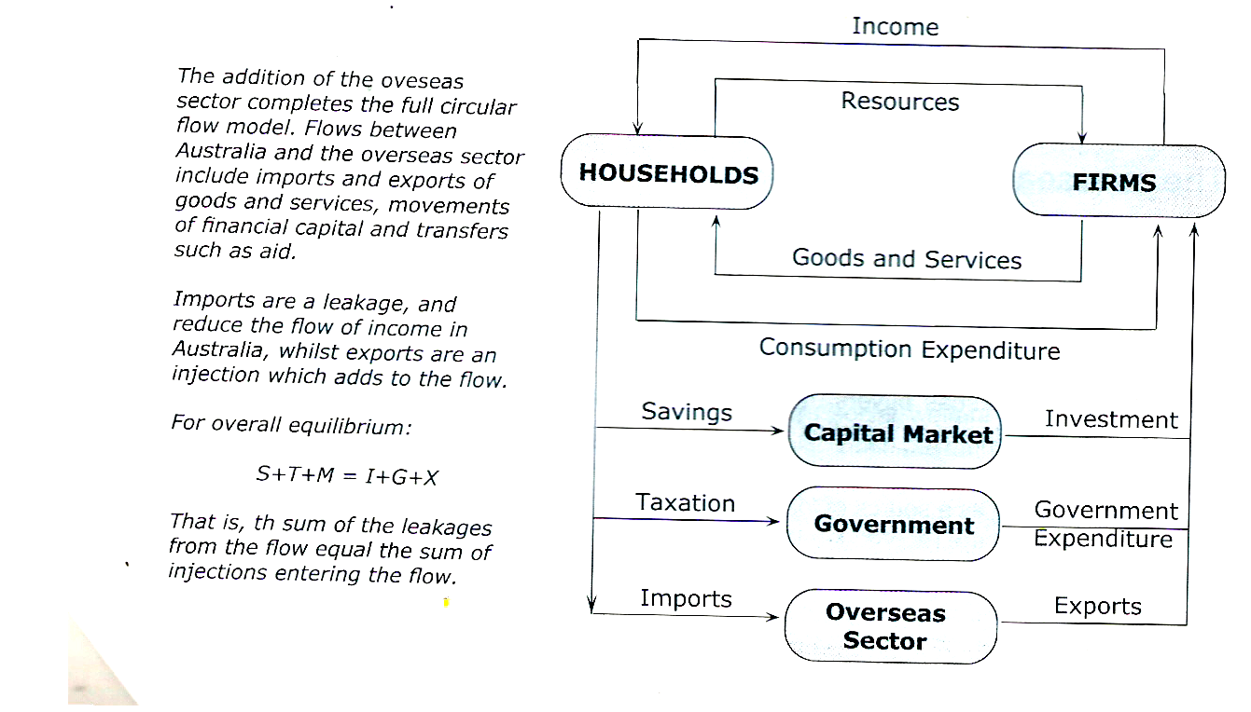
Circular Flow - Four Sectors

Households: owners of productive resources (Land, labour, capital and enterprise) and are consumers of goods and services.
Firms are employers of resources, and produce all the goods and services for the economy.
Capital market consists of financial institutions such as banks, credit unions and superannuation funds. These act as an intermediary or middleman between savers and investors. They attract funds by offering interest on savings, and then make these funds available to borrowers at a higher rate of interest so that they could cover operating cost and make a profit.
Government plays an important role in the economy. It reduces household income through a range of taxation measures. Government spending, like investment, is an injection to the flow of income.
The overseas sector represents import and export off goods and services as well as movements of financial capital. (5 x1)
Diagram (2)
Explain leakages and injections for each sector (3)
Explain Equilibrium (2)
(b) Explain the effect upon the circular flow of income of an inequality between planned savings and planned investment. (8)

Explain Savings and Investment (2)
Equations (2)
Y= C + S
O = C + I
Y = O
Explain Equilibrium (2)
C + S = C + I
S = I
Economy not always in equilibrium, disequilibrium is probably the normal state of the economy because of the independence of savings and investment decisions.

Savings > Investments
Investments > Savings (2)

36. (a) Explain why inflation would cause stock market prices to fall. (3)

- Industry conditions
- Overseas events
- Government policy
- The business cycle
- Expectations

(b) What are the factors that affect the share prices? (3)
Company specific factors
    - Profit performance
    - Company announcements
    - Takeover bids
    - Management strategies
    - Expectations / rumours

Other factors
- Industry conditions
- Overseas events
- Government policy
- The business cycle
- Expectations

(c) Explain the usefulness of share price indices to share market traders. (6)
- Provides an overall look at the state of the market from day to day.
- Recognised guide to the overall state of the Australian Economy.

(d) Using appropriate diagrams, show how the price of a share is governed by the market
forces of demand and supply. (8)

Diagram for demand (2)
Explanation (2)

Diagram of Supply (2)
Explanation (2)
37. (a) Explain using appropriate diagram, the operation of an export subsidy. (7)

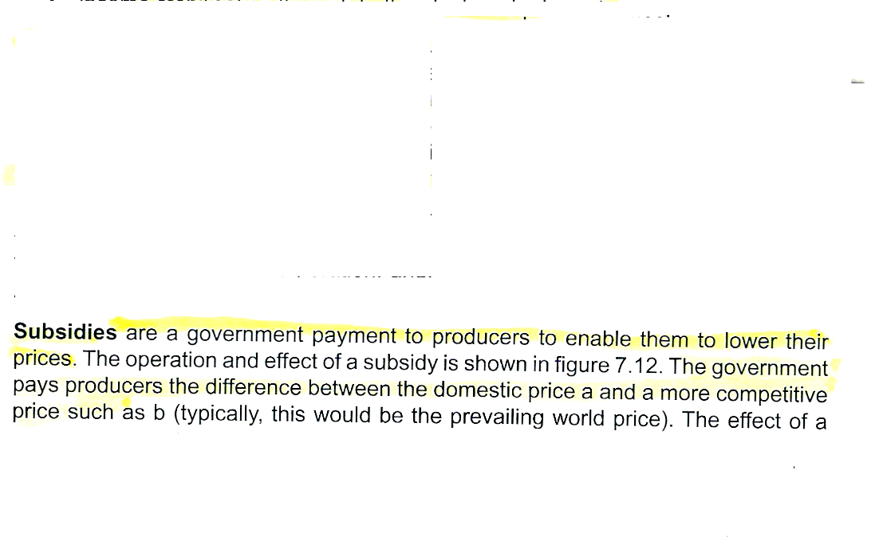

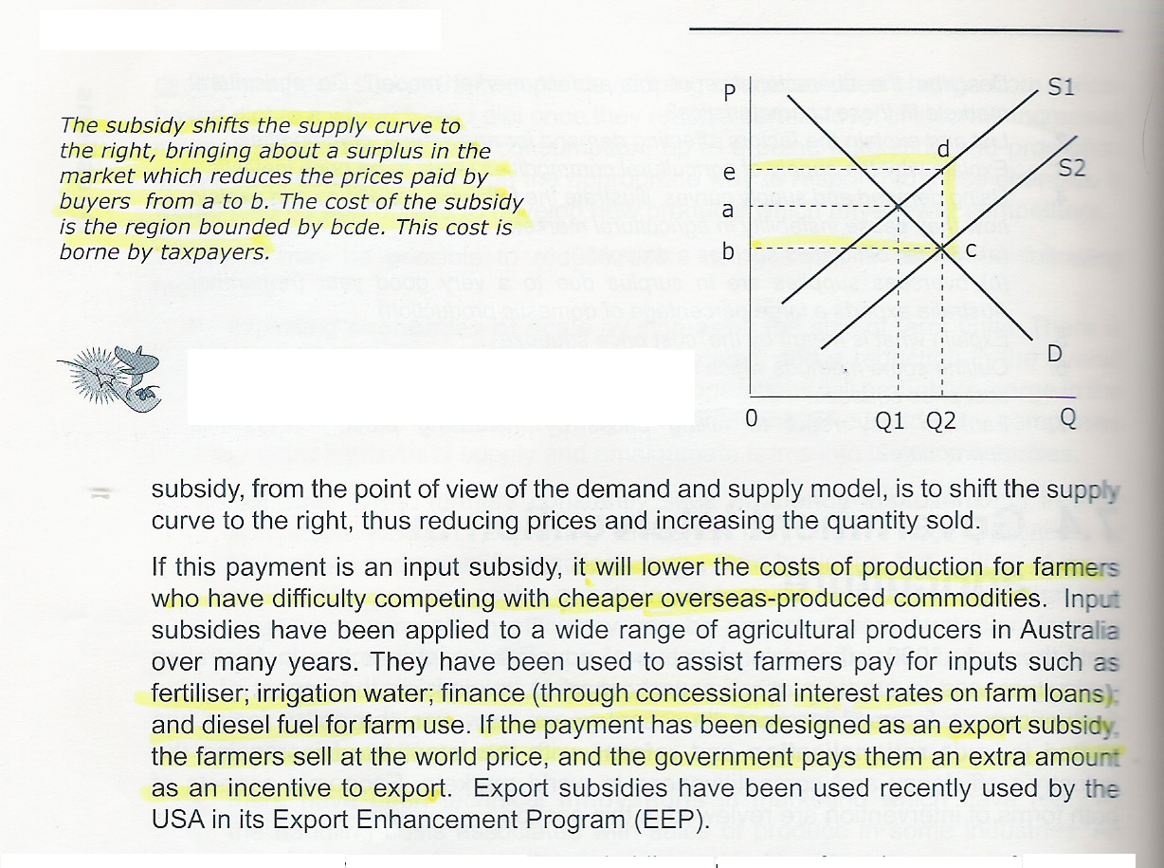

- Outline any five measures which farmers could use to reduce the pressures of cost price squeeze

- Exploiting economies of scale
- Efficiency Improvements
- Technical Innovations
- Reducing labour employed
- Sharing capital equipment and others to reduce costs
- Regulations of marketing of agricultural products.
- Protection of resources.
- Short term government intervention.
(5)

(c) ‘Pollution occurs because the environment is treated as a free good.’ Explain. (8)

Explanation of –free good
How does pollution take place?
Why does this happen

END OF PAPER

